VIDEO: Why ICER Threatens Patient Access to Life-Changing Treatments
Pioneer Institute urges policymakers to take caution when considering ICER.

Pioneer Institute has created a new, two-minute animated video, Why ICER Threatens Patient Access to Life-Changing Treatments, which illustrates the threat ICER poses to certain patient populations and medical innovation. The video explains what ICER is, how the QALY methodology of drug value assessment works, and why the adoption of ICER reviews by public and private payers could be detrimental for patients, especially older Americans and those living with a disability, a rare disease, or a chronic condition.
We encourage you to utilize – and customize as necessary – the following promotional materials to share this new video resource with your networks and advocacy partners.

Email Newsletter Template

TITLE: New Video: Why ICER Threatens Patient Access to Life-Changing Treatments

As states continue to grapple with prescription drug costs, policymakers are exploring potential ways to control costs and rein in drug pricing. “Cost-effectiveness” reviews are being considered as one method to determine if a drug’s price is justified by how effective it is. The Institute for Clinical and Economic Review (ICER) employs a method that utilizes a standard called “Quality Adjusted Life Year” (QALY), which assesses the “cost-effectiveness” of a drug based on an arbitrary monetary evaluation of one year of perfect health. The QALY method is based on financial considerations alone, ignoring patient preferences, undermining the patient-physician relationship, and potentially discriminating against older Americans and those with disabilities.

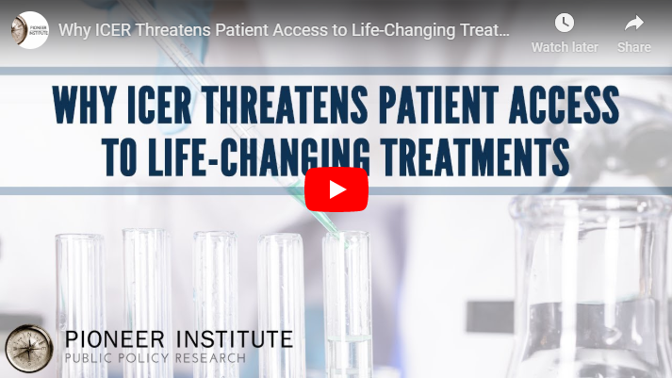

Pioneer Institute has created a new animated video, Why ICER Threatens Patient Access to Life-Changing Treatments, that explains what ICER is, how their methods threaten to limit access to innovative and life-saving treatments for certain patients, and why policymakers should take caution when considering policies that would adopt the use of ICER reviews.

- Watch the Video: Why ICER Threatens Patient Access to Life-Changing Treatments
- Learn More and Take Action: Protect Patients and Innovation from ICER

Social Media Content
Posts are customized for Twitter character limits.

- ICER's cost-effectiveness reviews of drugs could have a big impact on patient access to care. A new @PioneerBoston video explains what ICER is and why their method for assessing the value of treatments poses a threat to patients everywhere: https://youtu.be/mCjkRYr9kC0

- When the U.K. adopted the QALY methodology to determine drug treatment access, they had to ration care. Now, ICER is trying to bring QALY to the U.S. A new video from @PioneerBoston explains why policymakers should take caution when considering ICER: https://youtu.be/mCjkRYr9kC0

- ICER’s “one-size-fits-all” approach to measuring #healthcare value could LIMIT patient access to life-changing treatments, particularly for the elderly, those with a disability & patients with a rare or chronic disease. Learn more here from @PioneerBoston: https://youtu.be/mCjkRYr9kC0

- ICER: A little-known research group that could soon have a big effect on patient access to care. Watch a new video from @PioneerBoston to understand why ICER is bad for patients and NOT the answer for policymakers trying to rein in healthcare costs. https://youtu.be/mCjkRYr9kC0

- State and federal policymakers should take caution when considering ICER. They’re not the answer to control drug costs. @PioneerBoston breaks down what ICER is and why the “Quality Adjusted Life Years (QALY)” methodology they use is flawed ➡ https://youtu.be/mCjkRYr9kC0

